**Smart Retail Performance Monitor Dashboard**

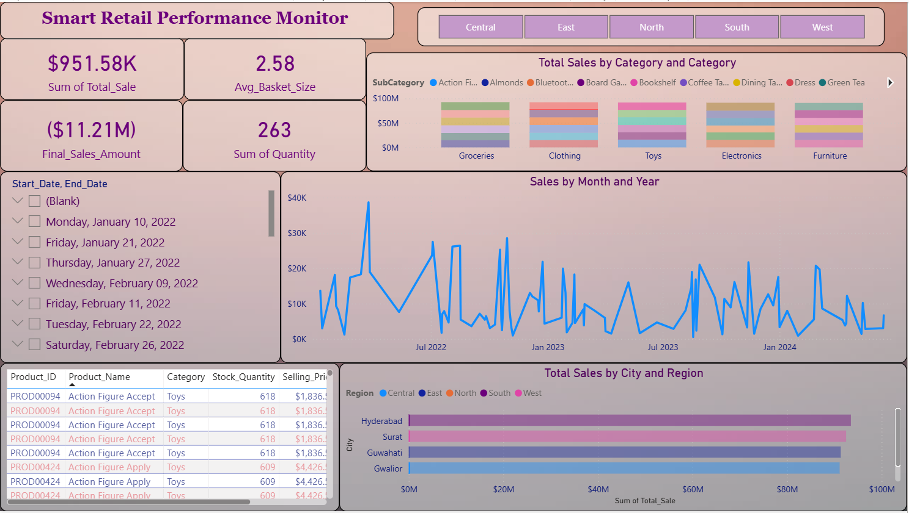

**Overview**

The Smart Retail Performance Monitor is an interactive Power BI dashboard designed to track key retail performance metrics such as sales, basket size, product categories, regions, and date-specific trends. It enables stakeholders to make informed decisions based on dynamic retail data insights.

**Objective**

* Monitor retail sales trends and profitability across regions.
* Analyze customer buying patterns and average basket size.
* Track product performance and inventory movement.
* Provide actionable insights for store and supply chain optimization.

**Data Sources**

This dashboard is based on normalized retail data, including:

* **Sales Transactions**
* **Products & Categories**
* **Date Information**
* **City and Regional Data**
* **Stock & Pricing Info**

**Key KPIs Displayed**

| **KPI** | **Value** | **Description** |
| --- | --- | --- |
| 💰 **Sum of Total Sale** | $951.58K | Total sales generated from all transactions |
| 🧺 **Avg Basket Size** | 2.58 | Average number of products per order |
| 📉 **Final Sales Amount** | ($11.21M) | Post-discounted or loss-adjusted final sales amount |
| 📦 **Sum of Quantity** | 263 | Total quantity of units sold |

**Visual Components and Insights**

**1. Sales by Category and Sub-Category (Stacked Bar)**

* **Categories:** Groceries, Clothing, Toys, Electronics, Furniture
* **SubCategories (Examples):** Action Figures, Almonds, Board Games, Dress, Green Tea
* **Insight:** Sales are evenly distributed across main categories; each consists of multiple subcategories.

**2. Sales by Month and Year (Line Chart)**

* **Time Range:** 2022–2024
* **Insight:** Peaks in sales are visible during festive and end-of-year months; seasonality observed.

**3. Sales by City and Region (Bar Chart)**

* **Cities Covered:** Hyderabad, Surat, Guwahati, Gwalior, etc.
* **Regions:** Central, East, North, South, West
* **Insight:** Cities like Hyderabad and Surat show significantly higher sales volumes.

**4. Date Filter (Checklist Slicer)**

* Allows selection of specific transaction date ranges to filter data dynamically.

**5. Product Table View**

* Displays details such as:
  + Product ID
  + Product Name
  + Category
  + Stock Quantity
  + Selling Price
* **Insight:** Helps with inventory analysis and price tracking.

**Filters & Interactivity**

* **Region Filter Buttons:** Central, East, North, South, West
* **Date Slicer:** Specific transaction or reporting dates
* **Category/Subcategory Drilldowns:** Embedded in charts

**Key Business Insights**

* **Sales Optimization:** Top-performing cities and regions can be prioritized for marketing and supply chain focus.
* **Inventory Planning:** Monitoring stock quantity and high-selling items aids in replenishment planning.
* **Profit Monitoring:** The negative final sales value suggests significant losses or discounts – a red flag for financial auditing.
* **Product Performance:** Action Figures and Electronics appear frequently in high sales – indicating popular categories.

**Technology Used**

* **Visualization Tool:** Microsoft Power BI
* **ETL Tool:** Power Query
* **Calculations:** DAX for measures like Avg_Basket_Size, Final_Sales_Amount
* **Visualization Types:** Line charts, bar charts, stacked columns, table view

**Future Enhancements**

* Add customer segmentation and demographics.
* Integrate product return data and reasons.
* Include real-time inventory alerts and reorder triggers.
* Visualize customer lifetime value (CLV) and churn rate.